Optimal control of chilled water pump operation to reduce HVAC energy consumption

Timotius Kelvin Wijaya^{a,*}, Nasruddinª , Sholahudin^{b}

ªDepartment of Mechanical Engineering, University of Indonesia, Depok 16424, Indonesia
^{b}Department of Applied Mechanics and Aerospace Engineering, Waseda University, Tokyo, 169-8555, Japan

*Corresponding author:
E-mail : timotius.kelvin@ui.ac.id
Tel/Fax : +6282122581717

Abstract
Energy consumption in building is increased significantly due to higher demand on cooling systems. This system consumes a large share of total building energy usage. A proper operation control strategy for this system promises the large energy saving. This paper proposes the optimization of water pump to control the chiller operation in a building. The method is developed by combining the artificial neural network and genetic algorithm. This study aims to develop the control method that can determine the optimal mass flow rate of chilled water to absorb the heat on cooling system during the operation. The building energy performances are modeled by Energy Plus software. Then the control strategy is developed by integrating Matlab and BCVTB (Building Controls Virtual Test). The dynamic optimization on mass flow rate is carried out continuously during real time operation. The developed control performance has been tested under various operating condition including variable outdoor temperature, sudden change of load condition, and different indoor temperature set point. The results show that the optimization of chilled water flow rate operation on large cooling system could reduce the electricity usage as 67,675%.

Keywords : Optimization, Building performance, Energy efficiency, Air conditioning.

Introduction
The increased population and social growth leads a crucial factor on higher energy usage. As the global energy generations are still dominated by fossil fuels, the large energy consumption makes the global greenhouse gas (GHG) emission increases rapidly [1]. The energy demand in Indonesia has dramatically increased up to more than 50% in 2020 [2]. The household sectors spent almost 40% of the total primary energy [3], where around 40% are utilized by cooling systems [4]. The other statistics reports estimate that around 30–50% of the total electricity consumption on the buildings is related to air conditioning (AC) systems operation [5]. Thus, the improvement of building energy efficiency through cooling systems is required to reduce the energy demand on household sector.
The improvements of AC systems have been carried out in previous works with focusing on system components such as heat exchangers [6, 7], compressor [8], and expansion valve [9]. However, the significant improvement on the cooling system available on the market is not appeared yet during the last decade [10]. The proper control strategy for the system operation offers the significant energy reduction as the systems work most of the time.
Most of control developments on HVAC system are focused on compressor operation as it consumes the most energy compared to other components [8]. The optimized operational strategy on heating ventilating and air conditioning (HVAC) system has been introduced in [11]. The paper described a critical review of current modeling techniques used in HVAC systems regarding their applicability and ease of acceptance in practice and summarizes the strengths, weaknesses, applications and performance of these modeling techniques. This review aims at highlighting the shortcomings of existing application-based research on HVAC systems, and accordingly, recommendations are presented to improve the performance of building HVAC systems.

However, the optimation of chilled water pump is very limited although bla blba. the operation on chilled water also has large contribution for energy saving in large HVAC system. The effect of chilled water pump operation on HVAC system performance has been investigated in [18]. The results found that the minimization of unnecessary transitional status of chilled water pump could save electricity by 2.72% [18]. Another Yu et al.’s study, considers how to apply optimum condensing temperature control and variable chilled water flow to increase the coefficient of performance (COP) of air cooled centrifugal chillers. There is 16.3–21.0% reduction in the annual electricity consumption of the building’s chiller plant [20]. Lee et al. [19] introduces a hybrid optimization algorithm that combines the particle swarm optimization algorithm and the Hooke–Jeeves algorithm to identify the optimal settings and minimize the energy consumption of chilled water system. The Results show some reduction of total energy consumed by the chilled water system by 9.4% in summer and 11.1% in winter compared to conventional settings [19]. All of this result indicates that the optimal control for chilled water pump should be considered to reduce energy consumption on HVAC systems.

The control developments on chilled water pump of HVAC systems have been conducted in previous studies [18-20]. Another breakthrough alternative way to optimize and control the HVAC system is to optimize the flow rate of chilled water using variable speed devices. Over the last few decades, the cost of speed devices has dropped significantly due to technological advances and the many widespread applications of variable speed pumps in building air conditioning systems [22]. Variable speed pump is very promising in the future if it can be controlled and optimized very well. However, this is difficult and requires a lot of research. Many research done this optimization using by developing and applying proper and optimal control algorithms for variable speed pumps to enhance their energy efficiencies of chiller.

In Z. Ma et al.’s study, presents the optimal control strategies for variable speed pumps with different configurations in complex building air conditioning systems to enhance their energy efficiencies. Through a detailed analysis of the system characteristics, the pressure drop models for different water networks in complex air conditioning systems are developed and then used to formulate an optimal pump sequence control strategy. The speeds of pumps distributing water to heat exchanges are controlled using a water flow controller. The results showed that about 12–32% of pump energy could be saved by using these optimal control strategies [22]. That study that mentioned is done by make physical model to create optimal control of variable speed pump. Physical model requires a lot of detail parameters, expensive and time consuming to make. Sometimes it is impossible to build a large/complex model.

In Gao et al.’s study, presents an energy efficient control strategy for secondary chilled water pump systems. The strategy employs the flow–limiting technique that ensures the water flow of secondary loop, not exceed that of the primary loop while still maintaining highest possible delivery capacity of cooling to terminals and integrated with a differential pressure set–point optimizer to determine the optimal set–point using PID controller to compare the measured water flow rate. The energy saving in the secondary chilled water pumps can be up to over 70% at system starting and 50% normal operation periods compared with the other strategies [21]. However the PID controls has some disadvantages if the input signal is far away from designed point has poor accuracy control.
Therefore this paper presents optimal control strategy for chilled water pump operation using ANN and GA. The importance of neural network is to cover the disadvantages of the common physical model. Nowadays, many neural networks are used in papers as prediction models and further could be implemented to control the modelled plant.
In Čongradac et al.’s study, presents the importance of using optimization of chillers operating using artificial neural networks and genetic algorithms. For the needs of generating chiller models, an artificial neural network was used and trained with data collected from an actual chiller. The results of using artificial intelligence methods in optimization of chiller operation were verified through an actual office building model created in the simulation software EnergyPlus and through a series of experiments on an actual office building [23].
The artificial neural networks (ANN) have been done a lot for HVAC systems and chiller research such as Hot water temperature prediction for adsorption chiller [24], cooling load forecasting for chiller plants [25], and there are many more research study, focusing on using ANN on the optimization of HVAC systems and chillers [11] and Nassrudin et al, optimized radiant cooling using ANN [12].
Lee et al.’s study, aimed at developing a control algorithm that can operate a conventional VAV system with optimal set–points for the (Air Handling Unit Discharge Air Temperature) AHU DAT. Three–story office building was modeled using co–simulation technique between EnergyPlus and Matlab via BCVTB (Building Controls Virtual Test Bed). In addition, artificial neural network (ANN) model, which was designed to predict the cooling energy consumption for the upcoming next time–step, was embedded into the control algorithm using neural network toolbox within Matlab. By comparing the predicted energy for the different set–points of the AHU DAT, the control algorithm can determine the most energy–effective AHU DAT set–point to minimize the cooling energy. The results showed that the prediction accuracy between simulated and predicted outcomes turned out to have a low coefficient of variation root mean square error (CvRMSE) value of approximately 24% [26].
Lee et al. have predicted the cooling energy consumption model with high accuracy. With the addition of optimization algorithms for real buildings, real conditions, and real thermal load data, this research can be further developed so that it can provide sophisticated and advanced control system applications.
Escandón et al. have develop a surrogate model to speed up the thermal comfort prediction for any member of a building category, ensuring high reliability by testing the entire simulation process with real data measured in-situ. To this end, an artificial neural network (ANN) is generated under MATLAB® environment using the data obtained from EnergyPlus simulations for linear-type social housing multi-family buildings in southern Spain, which were constructed in the post-war period. The developed ANN provides a regression coefficient between simulation targets and ANN outputs of 0.96, with a relative error between monitored and simulated data below 9%. A further result is that the building category characterization shows a general lack of suitable indoor thermal comfort conditions, thereby showing the great need for effective retrofit strategies. [27].
Escandón’s papers have predicted the cooling energy consumption model with high accuracy. With the addition of optimization algorithms and implementation of ANN model this research can be further developed so that it can provide sophisticated and advanced control system applications.

The main motivation of this research is to improve MAC UI chilled water pump, which is VSD currently not being implemented, is still using single speed constant pump. The electricity consumption from the pump also needs to be considered because it is the highest consumption in the cooling system after the compressor, even though the electricity consumption is less than the compressor. if the cooling system is used on a large scale there is great potential for energy savings on buildings. Many pumps are optimized with simple controls such as on/off control [28, 29], but with the advancement of VSD technology, sophisticated and advanced control systems can be implemented.
All of papers discussed in aforementioned literature there are still not yet implementing artificial neural network to improve HVAC optimization on chilled water pump. This paper aims to implement artificial neural networks and genetic algorithms to develop and improve the optimization of the mass flow rate of chilled water in the chiller cooling system. By using a control system that can determine the most optimal mass water flow rate to minimize electricity consumption from a chiller cooling system that already uses a part load system, especially on the power of the chiller pump while maintaining the desired room temperature. The control system is built using ANN (artificial neural network) and optimization of genetic algorithms. Observations and measurements are also carried out on the building and the chiller prior to the simulation modeling and optimization application.

Methodology

Research flow chart
This research consists of several parts: making a chiller system modeling, creating an artificial neural network, performing genetic algorithm optimization and making and testing control algorithms which can be seen in Fig. 1 shows the overall flow chart this study.
Start
Choosing buildings, rooms and HVAC systems to be used as simulation models
Conducting Observations & Measurements of the Building, Room and HVAC System
Making Geometry Modeling and Building Construction
Making HVAC System Modeling
Building, Room and HVAC Experiment Validation.
Determine the type of control system using ANN & GA
Determining Input & Output on ANN
Creating Random Signal Data for ANN Training
Forming the Fitness Function from ANN
Testing Fitness Functions in GA
Comparing ANN & GA control system with ON/OFF control system
Result Analysis Comparison of 2 control systems
Implementing System Control on pumps in order to control Room Temperature in HVAC simulations
Conclusion
End
Incompatible with Observation
Not yet pointing to the given setpoint
Already leading to the setpoint
which are given
Compatible with Observation
Fig. 1. Research flowchart.

MAC UI building and HVAC measurement
In terms of building modeling for simulation, the shape of the building (Makara Art Center building) is shown in Fig. 2. The measurements are taken to perform the simulation design. In this study, the building size for the simulation is about 60 m × 40 m (2400 m2) and from floor to floor the office building height per floor is about 4-5 meters.
Fig. 2. (a) actual MAC building; (b) Simulation building model
During the field test measurement, the building was occupied to detect uncontrollable impacts from occupants. The sensors are in good quality and has been calibrated and were maintained periodically. The building was instrumented with a variety of sensors, using Hioki LR5001 data logger to measure temperature and humidity, using PQA HIOKI PW3198 to measure voltage, current and power of the building, using WELTER electromagnetic flow meter to measure chilled water flow rate. Accuracy of each measurement tools can be seen at Table 1. The weather data using very specific weather data in Depok city. All the measured data was collected per second.
Table 1 List of sensor tools accuracy
Sensor tools | Measure | Accuracy
Hioki LR5001 | Room temperature | ±0.5 °C
 | Room humidity | ±5% RH
PQA HIOKI PW3198 | Voltage | ±0.1% of nominal voltage
 | Current | ±0.2% rdg. ±0.1% f.s.+ Clamp-on sensor accuracy
 | Power | ±0.2% rdg. ±0.1% f.s.+ Clamp-on sensor accuracy
WELTER flow meter | Chilled water flow rate | ±0.50% of nominal flow rate

Modeling of building, chiller and HVAC plants
The Makara Art Center Building University of Indonesia (MAC UI) is designed only 2 floors. Due to a lack of information sources for floors 3 and above. The building to be analyzed was selected as a virtual office building with a WWR (window to wall ratio) design of approximately 40%. The geometrical modelling can be shown at Fig. 4.
The HVAC modeling conditions determined from the results of the simulation model are: The building uses Chiller cooling in 1 Auditorium zone only. The building uses Split Duct Cooling in 9 Zones, the Lobby zone on the 1st & 2nd floor, office space 1, 2, 3, 4, gallery control room, and gallery floor 1 & 2. There are 2 types of HVAC used to cool the building, cooling using chiller and using Split Duct Cooling. Modeling on the chiller plant can be seen in Table 2 based on chiller at Fig. 5. The parameter conditions in Table 3 are determined based on measurement on the chiller characteristic performance.

Table 2 Material characteristics in buildings for simulation
Construction | Materials | Conductivity [W/m.K] | Thermal resistance [m².K /W]
Interior ceiling | 100 mm lightweight concrete | 0.53
 | Ceiling air space resistance |  | 0.18
 | Acoustic tiles | 0.06
Interior Wall | 19 mm gypsum board | 0.16
 | Wall air space resistance |  | 0.15
Interior Floor | Acoustic tiles | 0.06
 | Air space resistance |  | 0.18
 | 100 mm lightweight concrete | 0.53
 | Carpet pad |  | 0.1
Interior Partition | 25 mm wood | 0.15
Interior Window | Clear 3 mm | 0.9
Exterior Window | Theoretical Glass | 0.0133
Interior Door | 25 mm wood | 0.15
Roof | Roof Membrane | 0.16
 | Roof Insulation | 0.049
 | Metal Decking | 45.006
Exterior Wall | 1 inch Stucco | 0.69
 | 8 inch concrete HW | 0.17
 | Wall insulation | 0.08
 | ½ inch gypsum | 0.16

Table 3 HVAC & plant system specification.
HVAC & Plant | Value
Rated Cooling Capacity | 196 kW
Chiller rated COP | 4.0
Average Water Mass flow rate | 9.66 kg/s

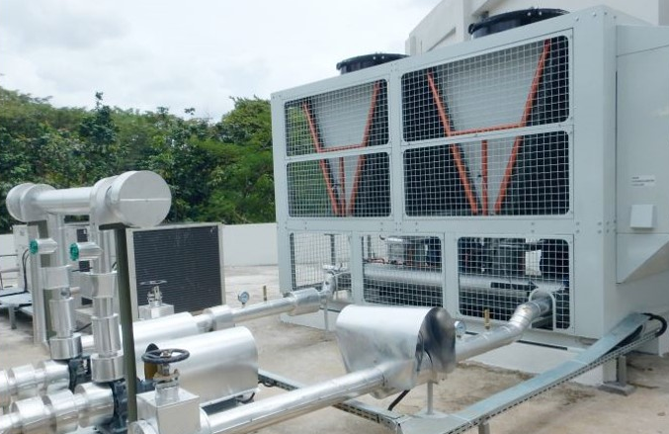
Fig. 5 Air-Cooled Chiller of MAC Building.

Fan performance modeling
Additional input includes parameters for modeling fan performance over a range of fan speeds. engineering documentation for the variable speed fan for a further description of what these coefficients represent. Commonly-used values for different variable volume systems are shown in the following Table 4. This research use the fan performance curve of Variable Speed Motor.
Table 4
Fan Coefficient Values.
Type of Fan | Fan Coeff. 1 | Fan Coeff. 2 | Fan Coeff. 3 | Fan Coeff. 4 | Fan Coeff. 5
Var. Speed Motor | 0.0015302446 | 0.0052080574 | 1.1086242 | -0.11635563 | 0.000

Chiller performance modeling based on PLR
This model simulates the thermal performance of the chiller and the power consumption of the compressor. The chiller model uses user-provided performance information at the reference condition along with three performance curves (curve objects) for cooling capacity and efficiency to determine chiller operation under off-reference conditions [30,31].
The three performance curves are:
1. Temperature Curve Cooling Capacity Function (ChillerCapFTemp)
2. Input Energy to Output Function Temperature Curve Ratio (ChillerEIRFTemp)
3. Input Energy to Cooling Ratio Output Function of Part Load Ratio Curve
(ChillerEIRFPLR)
The Function of Temperature Curve Cooling Capacity with the chiller reciprocating model on EnergyPlus:
$$Chiller RecipCapFTemp=0,507883+0,145228\left(T_{cw,ls}\right)-0,00625644{\left(T_{cw,ls}\right)}^{2}-0,0011178\left(T_{cond,e}\right)-0,0001296{\left(T_{cond,e}\right)}^{2}+-0,00028188\left(T_{cw,ls}\right)\left(T_{cond,e}\right)$$ | (2.1)
Chiller RecipCapFTemp is a cooling capacity factor, equal to 1 at reference conditions .; Tcw, ls is the setpoint temperature of cold water leaving (◦C). ; Tcond,e is the temperature of the incoming condenser liquid (◦C).

Energy Input to Output Function Temperature Curve Ratio with the chiller reciprocating model on EnergyPlus:
$$Chiller RecipEIRFTemp=1,03076-0,103536\left(T_{cw,l}\right)+0,00710208{\left(T_{cw,l}\right)}^{2}+0,0093186\left(T_{cond,e}\right)+0,00031752{\left(T_{cond,e}\right)}^{2}+-0,00104328\left(T_{cw,l}\right)\left(T_{cond,e}\right)$$ | (2.2)
Chiller RecipEIRFTemp is the energy input for the cooling output factor, equal to one at the reference condition; Tcw, l is the remaining cold water temperature (◦C); Tcond, e is the temperature of the incoming condenser liquid (◦C);

Energy Input for Output Function Cooling Ratio of Part Load Ratio Curve with chiller reciprocating model on EnergyPlus:
$$Chiller RecipEIRPLR=0,088065+1,137742\left(PLR\right)+0,225806{\left(PLR\right)}^{2}$$ | (2.3)
Chiller RecipEIRFPLR = input energy to the output cooling factor, equal to 1 under reference conditions; PLR = Part load ratio = (cooling load) / (chiller available cooling capacity);

Chiller simulation conditions
Some simulation conditioning is carried out when the chiller starts. This condition is based on observations of conditions in the field. All conditions that can affect room temperature, RH and electricity are recorded for inclusion in the schedule found in the EnergyPlus 9.2 simulation software. There is also an internal heat gain condition which can be seen in Table 5. The conditions included in plus energy are Occupancy, Lightning, Electric Equipment, HVAC Availability and Infiltration. The Schedule Graph can be seen in Fig. 6.
Table 5 Internal Heat Gain Condition
Type (Auditorium zone) | Value
Occupancy | 0.7739 m²/person
Light | 763.818 Watt
Equipment | 50 Watt/m²

Fig. 6. Fraction of simulation input schedule (a) occupancy, (b) HVAC, (c) Lightning, (d) equipment 1, (e) equipment 2

Validation of chiller results between experiments and models
Before using the simulation for optimization, it is necessary to carry out an error test in a simulation that is compared to the experiment results so that they match with the original. Comparison of the experiment results with the simulation results was carried out. This comparison covers 3 parameters, the room temperature parameter, the Relative Humidity parameter and the Total Building power parameter over the time (12.37 PM up to 18.00 PM). The room temperature comparison chart can be seen in Fig. 7 (a) which can be seen at the beginning of the graph, the temperature difference looks quite far. This is probably due to 2 things, the error when installing the thermostat at the beginning of the measurement may be influenced by the hand temperature during installation, causing the temperature measurement to be rather high and secondly, there is an error in making simulations, especially in adjusting the occupancy at the beginning of the measurement. Comparison graph for RH (room relative humidity) can be seen in Fig. 7 (b) which can be seen at the beginning of the chart looks very unstable. this is due to an error in the measurement installation in the room. RH measurements were carried out at 2 different location spots and the average was calculated, and Comparison graph for building electrical demand can be seen in Fig. 7 (c) which can be seen in the middle of the graph shows a decrease this is due to problems when the chiller is operated. The chiller is adjusted as it runs and causes it to drop. Assuming the use of electricity other than the chiller is constant / follows the schedule for other equipment. Error calculation for each parameter is carried out. Calculations were performed using 2 methods, RMSE (Root Mean Square Error) and MAPE (Mean Absolute Percentage Error). The calculation of the error value on each comparison graph for RMSE and MAPE room temperature is 0,11 and 1,33%, respectively. The result of error calculation for RMSE and MAPE of room RH is 2,22 and 2,01%, respectively, and last the of error calculation for RMSE and MAPE of total building electric demand is 7,87%. All the result of room/building error calculation can be seen in Table 6.

Fig. 7. Validation of simulation (a) Relative humidity (b) Room temperature

Table 6
RMSE and MAPE Calculation Results on Each Parameter
Data Type | RMSE | MAPE
Room temperature | 0,11 (°C) | 1,33%
Room relative hmidity | 2,22 (%) | 2,01%
Total Building Electric Demand | - | 7,87%

$$RMSE=\sqrt{\frac{1}{n}\sum_{i=1}^{n}{{\left(Pi-Ai\right)}^{2}}}$$ | (2.4)
Where 𝑃𝑖 is the predicted value at an interval and 𝐴𝑖 is the target value at an interval and 𝑛 is the amount of data available. Not the result of the error percentage because it is not multiplied by 100 percent.
$$MAPE= \frac{1}{n}\sum_{t=1}^{n}{\left|\frac{A_{t}-F_{t}}{A_{t}}\right|}$$ | (2.5)
At is the actual value and Ft is the approximate value. MAPE is reported as a percentage, which is the equation above multiplied by 100.

Control system on the chiller pump
The control system created will control the mass flow rate at the pump which will affect the room temperature. With feedback and setpoint adjusted from room temperature. Feedback from room temperature will cause the control system to adjust the mass flow rate of the pump which affects the room temperature cooling control Fig. 8.

Fig. 8. Schematic diagram of HVAC system
The Predictive Control System method is based on the receding horizon technique [32]. The Artificial Neural Network predicts the installation response over a specified time horizon. The predictions used by numerical optimization programs to determine control signals that define the following performance criteria over a specified horizon.
$$J= \sum_{j=N_{1}}^{N_{2}}{{\left(y_{r}\left(t+j\right)-y_{m}\left(t+j\right)\right)}^{2}}+ρ\sum_{j=1}^{N_{u}}{{\left(u^{'}\left(t+j-1\right)-u^{'}\left(t+j-2\right)\right)}^{2}}$$ | (2.6)
When $N_{1}$, $N_{2}$, dan $N_{u}$ in Equation 2.6 are used to determine the horizon by tracing the error and increasing the control that has been evaluated. The variable $u^{'}$ is the tentative (temporary) control signal, $y_{r}$ is the desired response, and $y_{m}$ is the network model response. The value of $ρ$ to determine the contribution of the sum of squares of the increase in control to the performance index. The block diagram in Fig. 9 illustrates the process of the Predictive Control Model. The controller consists of a neural network model block, a plant and an optimization block. The optimization block determines the value of $u^{'}$ which minimized $J$, and then the optimal $u^{'}$ is input to plant [33].
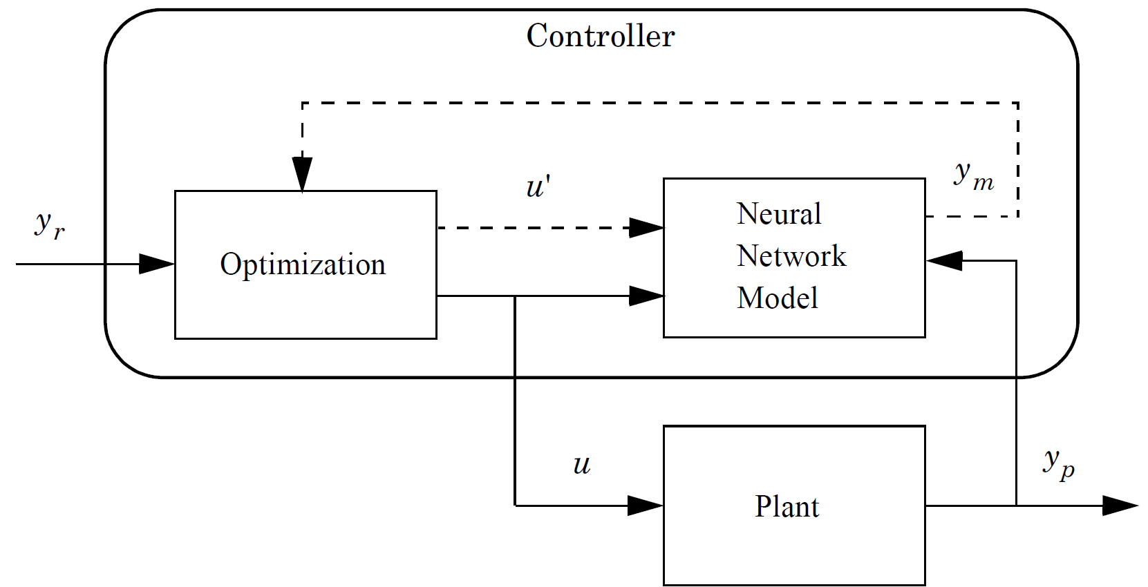
Fig. 9. Flowchart of the Predictive Control Model [33].

Artificial neural network learning process over the chiller model
Artificial neural network learning is carried out by entering the flow rate signal input to the pump (in the EnergyPlus software) randomly using a special random code in Matlab with a range from 0 to 1 and based on time units. The time unit can vary from minutes to hours depending on the time constant calculation obtained. The mass flow rate signal can be seen in Fig. 10.
Fig. 10. Random mass flow rate for ANN training.
Table 7 Table xx Input and output parameter of ANN prediction

Symbol | Parameter | Range | Input | Output
x₁ | Outdoor air dry bulb temperature (°C) | 22.1- 35.6 | ●
x₂ | Outdoor air relative humidity (%) | 49- 97 | ●
x₃ | Diffuse solar radiation (W/m2) | 0- 825 | ●
x₄ | Direct solar radiation (W/m2) | 0- 504 | ●
x₅ | Chilled water flow rate (kg/s) | 0- 1 | ●
y | Room temperature (°C) | 20.9- 28.4 |  | ●

Time constant is calculated by step response test. The hold time should be an ideal if a hold time to short leads to a system with insufficient time to settle down, if the hold time to long data can cause data redundancy at steady state condition [34]. Each signal is inputted for a period of one and a half hours which close to the time constant before the next signal is changed. The signal time period (time constant) is searched by making constant all variables in the weather file and all load schedules on EnergyPlus. This is done to determine the condition of the chiller when all conditions are given a constant of all. After knowing the time constant of the chiller then got the result (10078 data) to ANN for training process. The ANN learning process uses the Levenberg-Marquardt learning method [35, 36]. Using deep learning tools at Matlab software The input characteristics of the ANN can be seen in Table 7.

RMSE results on ANN
Existing data sets are used for the training and testing process. The 10078 data from simulation is randomize and split into 2 part training and testing. The 70% of data used for training and 30% for testing of data in 1 hidden layer with a total network of 20. The network error rate is the difference between the output produced by the artificial neural network and the target data. All the training and testing process of neural network done with Matlab software. The value is obtained by the RMSE formula. Based on the method used, Levenberg-Marquardt, each network has a calculation error process is carried out for each ANN structure. in Fig. 11. Fig. 12 shows the ANN structure with the smallest RMSE with 3 hidden neurons.

Fig. 12. ANN structure

Fig. 11. RMSE results for each neuron of 1 hidden layer

Optimization with genetic algorithm
Optimization is carried out with genetic algorithms to make accurate and optimal predictions using global optimization toolbox in Matlab [37]. Optimization is carried out using functions that have been generated by the ANN in Matlab. The genetic algorithm optimization, implemented in the simulation tool developed for the work presented in this paper, uses only three operators to produce a new population for the next generation – selection, crossover, and mutation [38] . Some of the optimization parameters can be seen in Table 8.
Table 8
Configuration parameter in genetic algorithms.
Number of variables | Value
Upper Bound | 1
Lower Bound | 0.001
Max Stall Generation | 50

The process of making a system control algorithm
Equation lines or error functions developed and trained by ANN in input values from the EnergyPlus software. Then ANN will produce a predictive room temperature result which will be reduced by the setpoint temperature.
$$Y= abs\left(Yann-Ysetpoint\right)$$ | (2.7)
The control algorithm is based on the difference between the result (Yann) temperature of the ANN line equation with the setpoint temperature (Ysetpoint). The difference is made into a positive (not negative) value using an absolute function. The result of the difference in temperature obtained used the optimization method of GA optimization to find the optimal value of the flow mass rate (x) before input into the plant (chiller).

Model control implementation process with BCVTB
Establish a co-simulation between EnergyPlus and MATLAB through the BCVTB (Building Controls Virtual Test Bed) platform to implement this. Building and system modeling for simulation is implemented via EnergyPlus using ExternalInterface and ExternalInterface: Schedule Object for co-simulation. The co-simulation diagram can be seen in Fig. 13 and Fig. 14. A co-simulation process was carried out between the EnergyPlus software and the Matlab software. Data exchange is carried out. The data exchange can be seen in Table 9. The data exchange process is carried out every 1 minute at the time in the software. There are 3 files on the BCVTB (Building Controls Virtual Test Bed) platform, 2 files from EnergyPlus and 1 file from MATLAB which are simulated simultaneously.
Table 9
Data Exchange Matlab with EnergyPlus on the BCVTB Platform.
EnergyPlus → Matlab | Matlab → EnergyPlus
Outdoor Air Dry-bulb Temperature [°C] | Mass Flow Rate Chiller [kg/s]
Outdoor Air Relative Humidity [%]
Diffuse Solar Radiation Rate per Area [W/ m²]
Direct Solar Radiation Rate per Area [W/ m²]
Room Temperature [°C]

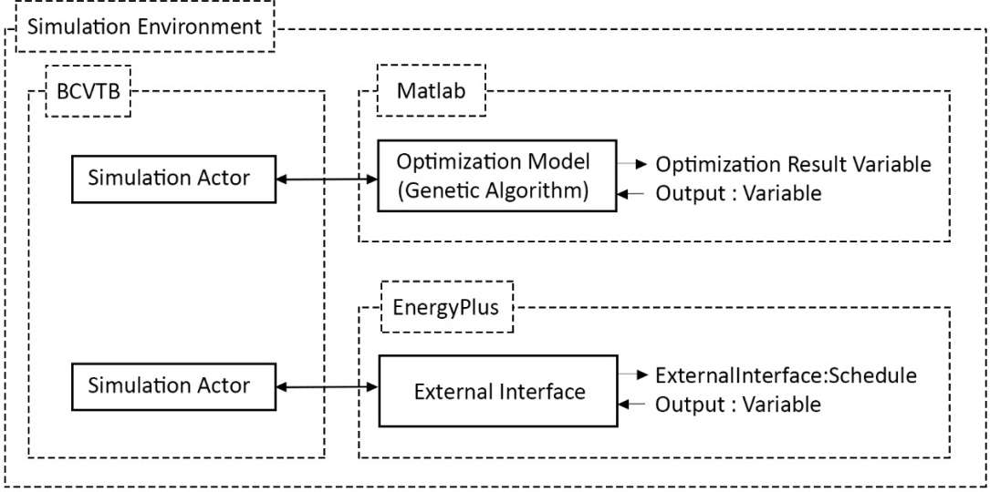
Fig. 13. Diagram on the BCVTB platform.
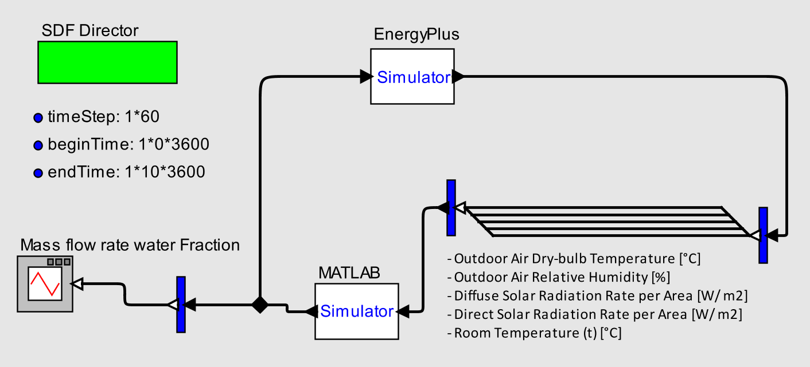
Fig. 14. Co-simulation diagram on BCVTB.

Process Flow of Software
This work is carried out using 5 different software SketchUp, OpenStudio, Matlab, EnergyPlus and BCVTB (Building Controls Virtual Test Bed). The process is carried out for the first time by creating building geometry with the SketchUp 2017 software, followed by OpenStudio software, determining the types of construction in the building such as material, ground height and others. OpenStudio 2.8.1 can generate Building constructions on EnergyPlus files in the form of IDF. EnergyPlus 9.2 simulates internal heat transfer and external heat transfer and generates an HVAC system with the loads. BCVTB 1.6.0 is software that allows users to pair various simulation programs to be simulated together [39]. Workflow can be seen in Fig. 15.
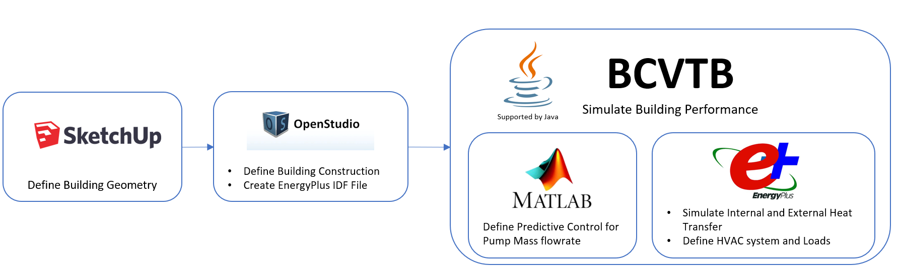
Fig. 15. Process flow on software.

Result and Discussion

Result of room temperature control validation according to set point
In Fig. 16, the simulation is carried out with each system (ON/OFF and control system) capable of controlling room temperature by approaching the predetermined setpoint temperature. Each setpoint temperature was changed every 120 minutes and 5 variations of the setpoint temperature were carried out. The reason for varying the setpoints is to see if the system is capable of performing the optimization and maintaining room temperature at any given setpoint. It can be seen that each systems can match at a specified set point although each system has a deviation. In the ON/OFF system there is a variation deviation of ± 0.5°C along the simulation time. and in the Optimized system there is a deviation of ± 0.2°C along the simulation time. Setpoints were carried out at 5 temperature points at the point (26°C, 25°C, 24°C, 23°C, 22°C).

Fig. 16. Room temperature comparison (Auditorium) between ON/OFF and optimized system, detail at the beginning of the chart, and at end of the chart.

Results of comparison of mass flow rate at chiller pump
In Fig. 17 each system (ON/OFF and Control System). It can be seen that in the ON/OFF system the mass flow rate changes from the maximum condition to the minimum (from 0 to 1 condition) because the control system is switched off and on using the switch principle. Unlike the control system which is carried out with the principle of optimization. Here it is seen that any change in the setpoint that affects this mass flow rate graph results in an increase in mass flow rate for several minutes. This is because the increase in mass flowrate affects the rate of cooling at room temperature. followed by a decrease in mass flowrate when the room temperature reaches a given setpoint. Here it is shown that the optimization has been successful by keeping room temperature with the minimum mass flow rate possible. It can be seen that at the 23°C and 22°C setpoints, it appears that the mass flow rate graph is rather high compared to the previous setpoint, this could be due to a large difference between the ambient temperature and the given setpoint temperature. With a large temperature difference, the temperature load is also getting bigger. With a large temperature load, a large mass flowrate is needed to keep the room temperature at a given setpoint. The comparison of the average for each system is made, obtained a difference of 67.675% in average.
Fig. 17. Comparison of mass flow rate on a pump between ON/OFF and optimized system, detail at the beginning of the chart, and at end of the chart.

Energy comparison results on chiller pumps
In Fig. 18 on each system (ON/OFF and Control System). It can be seen that this graph is similar to Fig. 17 because the pump power is affected by the RPM rotation because the pump design with the variable speed. RPM is influenced by the mass flow rate. the higher the rotating RPM, the greater the energy (watts) required to produce high RPM. Comparison of the average for each system was carried out, resulting in a savings of 67.675% in average.

Fig. 18. Pump power comparison between ON/OFF and optimized system, the detail at the beginning of the chart, and at end of the chart.

Control at sudden load change
This control system is tested for its performance under extreme conditions by using a simulation to see if this control system can redirect the temperature back to the given setpoint. This extreme condition is given suddenly for short time period. These extreme conditions are performed by simulations using actual Depok city weather data and real room in the field. the parameter made extreme is the heat load of occupancy which simulates when the room is visited by many people who exceed the comfortable capacity of the room. In general mostly PI controller only control at design point, when there is a fluctuation, the control cannot control and it will no longer direct according to the setpoint because the control system algorithm is messed up because it is given very large abnormal inputs.
Fig. 19. Room temperature comparison at two setpoint given the extreme condition.
This test uses 2 set points at points 26°C and 25°C shown at Fig. 19 because at this setpoint the room temperature is the most stable and appropriate at the setpoint and the mass flow rate is lowest or at minimum amount, this is because the difference in ambient temperature with the setpoint is almost has little difference that can be seen at the beginning of this graph (Fig. 20). This test was not carried out at 23°C and 22°C setpoints due to the large difference between the ambient temperature and the temperature setpoints which resulted in a large flow rate mass. The success of the control system in controlling extreme conditions by using two different setpoints, logically this control system can also control extreme conditions at setpoint 24°C. The optimized control system had a significant average difference with the ON/OFF control system around 50,78% over this test on two setpoint. The result comparison of pump power optimized and pump power ON/OFF that can be shown at Fig. 21 also had a system had a significant average difference with the ON/OFF control system around 50,78%.
Fig. 20. Mass flow rate comparison at two setpoint given the extreme condition.
Fig. 21. Power pump comparison at two setpoint given the extreme condition.

Conclusion
Based on the data analysis of the research results that have been carried out, it can be concluded that several things are the results of the comparison of the ON/OFF control system with the control system on the mass flow rate of the chiller pump on the chiller that has used the part load system, it can be seen that it can reduce pump electrical energy consumption by 67.675%. Testing the control algorithm for temperature control managed to control according to the desired setpoint with a deviation variation of ± 0.2 °C. The control system is tested at sudden load change with the result which the optimized control system had average different 50,78% lower than the ON/OFF control system. This control can be suggested for use in this existing building.

Reference
- M. H. Shamsi, U. Ali, E. Mangina, J. O'Donnell, A framework for uncertainty quantification in building heat demand simulations using reduced-order grey-box energy models, Applied Energy 275 (2020) 115141
- Nasruddin, Idrus Alhamid M, Daud Y, Surachman A, Sugiyono A, Aditya HB, et al. Potential of geothermal energy for electricity generation in Indonesia: a review. Renew Sustain Energy Rev 2016;53:733–40.
- W.W. Purwanto, Indonesia Energy and Outlook and Statistic 2006, Pengkajian Energy Universitas Indonesia, University of Indonesia, 2006.
- E. Prianto, Indonesian Landed House Electricity Consumption, Home Design Going Green, One Day Seminar, WWF–Indonesia, Jakarta, 2007
- A. Utama, S.H. Gheewala, Life cycle energy of single landed houses in Indonesia, Energy and Buildings 40 (2008) 1911–1916.
- M. Ahmadzadehtalatapeh, Y.H. Yau, The application of heat pipe heat exchangers to improve the air quality and reduce the energy consumption of the air conditioning system in a hospital ward—A full year model simulation, Energy and Buildings 43 (2011) 2344-2355
- P. A. Kew, David A. Reay, Compact/micro-heat exchangers—Their role in heat pumping equipment, Applied Thermal Engineering 31 (2011) 594-601
- K. Noh, B. Min, Sang-Jin Song, J. Yang, G. Choi, D. Kim,Compressor efficiency with cylinder slenderness ratio of rotary compressor at various compression ratios, International journal of Referigation 70 (2016) 42-56
- R. Zhang, E. J. Stanke, G. Zhang, Y. Lu, X. Sun, X. Li, Benefits investigation of electronic expansion valve in electric vehicle thermal system as compared to thermal expansion valve with shut-off valve, International journal of Referigation 100 (2019) 404-413
- D. Nishijima, Product lifetime, energy efficiency and climate change: A case study of air conditioners in Japan, Journal of Environmental Management 181 (2016), 582–589.
- Afroz, G.M. Shiafiullah, Modeling techniques used in building HVAC control systems: A review, Renewable and Sustainable Energy 83 (2018), 1364–0321.
- Nassrudin, Sholahudin, P Satrio, T.M.I. Mahlia, N. Gianneti, K Saito, Optimization of HVAC system energy consumption in a building using artificial neural network and multi–objective genetic algorithm, Sustainable Energy Technologies and Assessments 35 (2019), 48–57.
- J.R. Dobbs, B.M. Hencey, Model predictive HVAC control with online occupancy model, Energy and Buildings 82 (2014), 675–84. –
- A, Afram, F. Janabi–Sharifi, Theory and applications of HVAC control systems – A review of model predictive control (MPC), Building and Environment 72 (2014) 343–355.
- L. Lu, W. Cai, L. Xie, S. Li, Y.C. Soh, HVAC system optimization in – building section, Energy and Buildings 37 (2005), 11–22.
- D.V. Chase, L.E. Ormsbee, Computer-generated pumping schedules for satisfying operational objectives, Journal of the American Water Works Association 85 (7) (1993) 54–61.
- G. Yu, R.S. Powell, M.J.H. Sterling, Optimized pump scheduling in water distribution systems, Journal of Optimization Theory and Applications 83 (3) (1994) 463–488.
- F.W. Yu, W.T. Ho, Multivariate diagnosis analysis for chiller system for improving energy performance, Building Eng. 20 (2018), 317–326.
- K. Lee, T. Cheng, A simulation–optimization approach for energy efficiency of chilled water system, Energy and Buildings 54 (2012) 290–296.
- F.W. Yu, K.T. Chan, Improved energy performance of air cooled centrifugal chillers with variable chilled water flow, Energy Conversion and Management 49 (2008) 1595–1611.
- D. Gao, S. Wang, Y. Sun, A fault–tolerant and energy efficient kontrol strategy for primary–secondary chilled water systems in buildings, Energy. Buildings 43 (12) (2011), 3646–3656
- Z. Ma, S. Wang, Energy efficient control of variable speed pumps in complex building central air-conditioning systems, Energy and Buildings 41 (2009) 197–205.
- V. Čongradac, F. Kulić, Recognition of the importance of using artificial neural networks and genetik algorithms to optimize chiller operation, Energy. Buildings 47 (2012), 651–658
- Nassrudin, Sholahudin, M.I. Alhamid, K. Saito, Sustainable Energy Technologies and Assessments 30 (2018) 114–120.
- L. Wang, E.W.M. Lee, R.K.K. Yuen, W. Feng, Cooling load forecasting-based predictive optimisation for chiller plants, Energy & Buildings 198 (2019) 261–274.
- J.M. Lee, S. H Hong, B.M Seo, K.H. Lee Application of artificial neural networks for optimized AHU discharge air temperature set–point and minimized cooling energy in VAV system, Applied Thermal Engineering 153 (2019), 726–738.
- R. Escandón, F. Ascione, N. Bianco, G. M. Mauro, Rafael Suárez, J. J. Sendra, Thermal comfort prediction in a building category: Artificial neural network generation from calibrated models for a social housing stock in southern Europe, Applied Thermal Engineering 150 (2019) 492–505
- Raef S. Shehata, Hussein A. Abdullah, Fayez F.G. Areed, Variable structure surge control for constant speed centrifugal compressors, Control Engineering Practice 17 (2009) 815–833
- Masoud Taleb Ziabari, Mohammad Reza Jahed-Motlagh, Karim Salahshoor, Amin Ramezani & Ali Moarefianpur | (2017) Robust adaptive control of surge instability in constant speed centrifugal compressors using tube-MPC, Cogent Engineering, 4:1, 1339335
- The U.S. DOE. EnergyPlus Engineering Reference. The Reference to EnergyPlus. Calculations, Version 9.2; The U.S. DOE: Washington, DC, USA, 2019, pp. 769–774.
- The U.S. DOE. Getting Started. EnergyPlus Version 9.1.0 Documentation; The U.S. DOE: Washington, DC, USA, 2019.
- Soloway, D., and P.J. Haley, “Neural Generalized Predictive Control,” Proceedings of the 1996 IEEE International Symposium on Intelligent Control, 1996, pp. 277–281.
- M.H. Beale, M.T. Hagan, H.B. Demuth, Deep Learning Toolbox User’s Guide, MathWorks, 2020, pp. 1842.
- Sholahudin, K. Ohno, &. Giannetti, S. Yamaguchi, K. Saito Dynamic modeling of room temperature and thermodynamic efficiency for direct expansion air conditioning systems using Bayesian neural network, Applied Thermal Engineering 158 (2019) 113809.
- Marquardt, D., “An Algorithm for Least–Squares Estimation of Nonlinear Parameters,” SIAM Journal on Applied Mathematics, Vol. 11, No. 2, June 1963, pp. 431–441.
- Hagan, M.T., and M. Menhaj, “Training feed–forward networks with the Marquardt algorithm,” IEEE Transactions on Neural Networks, Vol. 5, No. 6, 1999, pp. 989–993, 1994.
- Global Optimization Toolbox User’s Guide, MathWorks, 2020, pp. 260, 267–272.
- D. Tuhus-Dubrow, M. Krarti, Genetic-algorithm based approach to optimize building envelope design for residential buildings, Building and Environment 45 (2010) 1574–1581.
- BCVTB., https://simulationresearch.lbl.gov/bcvtb/FrontPage, 2016.

